Monthly Report /#2

- Date of Report:1/8-31/8
- Student ID - Name: Mohammad Hani Alshenaiwer
- Major: Cybersecurity
- Company: Arab Bank
- Department: Security Assurance
- Industry Mentor: Sari Abu Qoura
- Apprenticeship Mentor: Shareef Shargawi
- Working days/hours:5 days a week / 7:30 hours
Your report must cover these topics:
- Your role and responsibilities this month (+ evidence)
My second month, I continued working with the security Assurance team, expanding my knowledge in responsibilities, to include version control and containerization tools. My main tasks include:
- Using GitHub for versions controls: I cloned repositories, created branches, committed code changes and pushed them back to the remote repository.
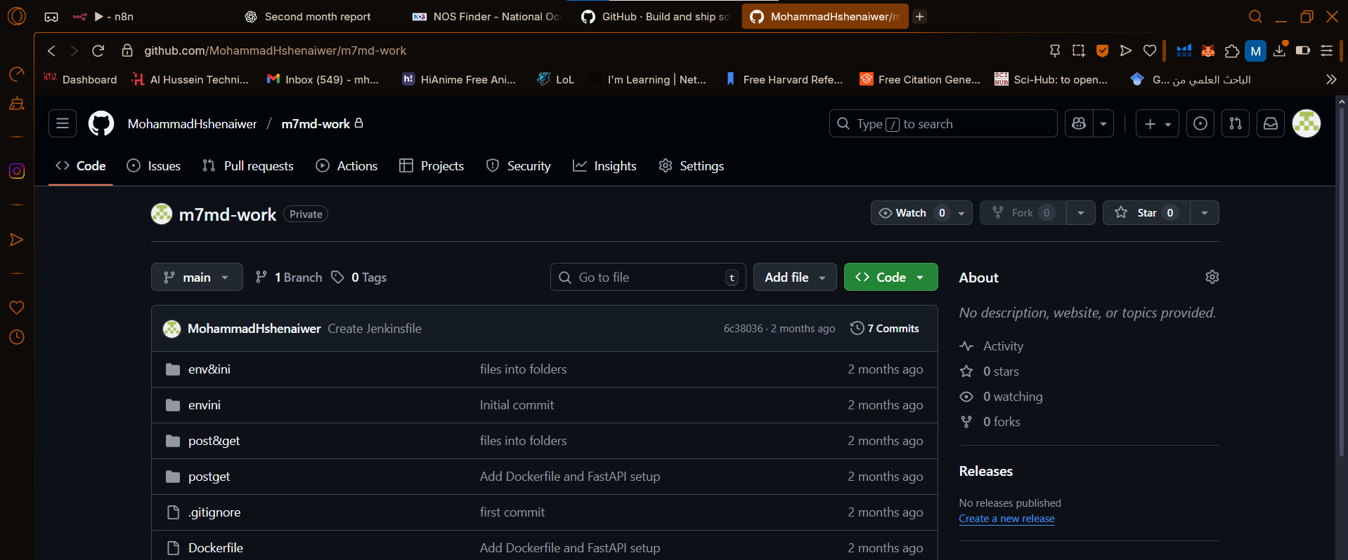
- Learning and using docker to containerize applications: I created Dockerfiles, built Docker images, and ran containers locally. I practiced deploying simple FastAPI applications inside Docker containers.
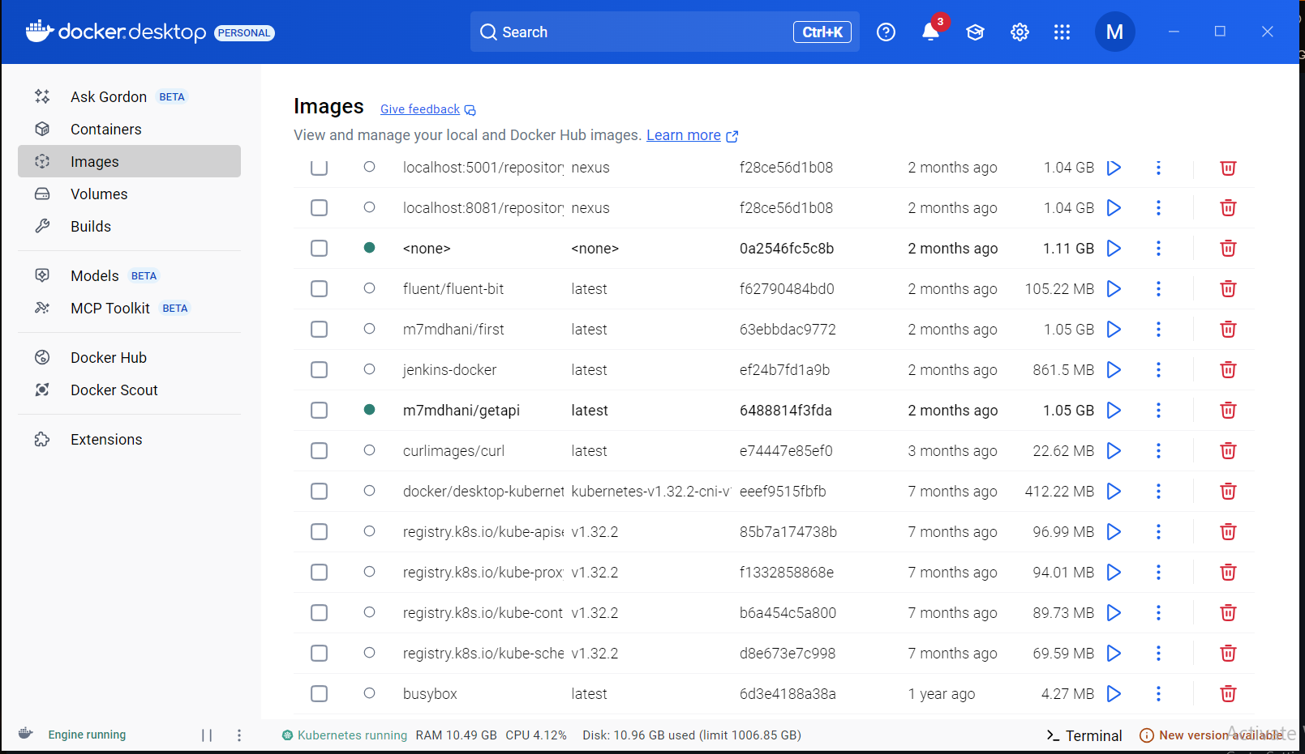
- Continuing exercises on FastAPI: I implemented more GET and POST APIs and tested them through Postman.
- Any problems / Challenges and how did you overcome them?
- Understanding docker commands and containerization concepts at first was difficult.
Using referred to online documentation and team collaboration
- Any training courses you attended during the apprenticeship, whether you opted for independently or through the employer.
  - Name of the course
  - Main Topics
  - Copy of certification
No courses were required in this month

- What software /tools did you use?
- Venv: environment to download the tools in VS code
- FastAPI to run the python codes that contains GET POST API in the localhost
- Postman: to access the APIs in a GUI platform
- Git & GitHub: Version control and collaboration
- Docker: Containerizing applications and managing local containers
- Technical and non-technical skills
- API writing in python
- Using Git and GitHub for version control
- Creating Dockerfiles and managing Docker containers

- Did you work on the National Occupational Standards (NOSs):
  - How many NOSs did you complete out of 5?
  - List of NOSs (Number (URN) – Name of NOS)
did not work in NOS in this month

- Events / Conferences you participated

- Your Plan for Next Month.
Doing the exercises that the team leader gives me

